

***Capstone Project***

**Report 2**

**Software Project Management Plan**

*Personal Finance Management*

**Author: PFM Team**

**Supervisor: Mr. Nguyen Van Hien**

**Hanoi, 2nd Oct, 2012**

Record of changes:

|  |  |  |  |  |
| --- | --- | --- | --- | --- |
| **Date** | **Change Item** | **Description** | **By** | **Version** |
| 02/10/2012 | All | Create the document | GamNT01326 | 1.0 |
|  |  |  |  |  |
|  |  |  |  |  |

Table of Contents

1. Problem Definition 4

**1.1. Name of this Capstone Project 4**

**1.2. Problem Abstract 4**

**1.3. Project Overview 6**

**1.3.1. The current System 6**

**1.3.2. The Proposed System** **8**

**1.3.3. Boundaries of the System 8**

**1.3.4. Development Environment 8**

2. Problem Organization 8

**2.1. Software Process Model 8**

**2.2. Roles and Responsibilities 8**

3. Project Management Plan 8

**3.1. Task Sheet: Assignments and Timetable 8**

**3.2. Risks Management 8**

**3.3. All Meeting Minutes 8**

4. Coding Convention 8

# Problem Definition

## Name of this Capstone Project

As introduction in Report 1, name of this project is **Personal Finance Management**. Abbreviation **PFM**

## Problem Abstract

Our product helps people manage their personal finance in the way of the most quickly and usefully, without waste of time to remember and don't afraid forget any account.

## Project Overview

### The current System

It will be a new system, developed by ourselves. There is no current system.

### The Proposed System

There are some main functions of our product (when completed):

* Schedule: use to plan your future spending
* Revenue and expenditure management: helps user manage revenue and expenditure every month
* Borrowing and lending management: help user to easily manage borrowing and lending.
* Report: analyze your spending with reports and pie charts; help user has an overview of the expenses in a month, compare with plan or other month.
* Warning: alert you of upcoming bills or when expenditures exceed plan.
* Synchronize: help storage data

### Boundaries of the System

* Final product is an application on Android
* Application for Vietnam
* The system will have to work Android 2.3 or higher

### Development Environment

* OS:
* Developing language
* IDE:
* Database:

# Problem Organization

## Software Process Model

We apply new process model named: Scrum. All phases of project will follow this model.

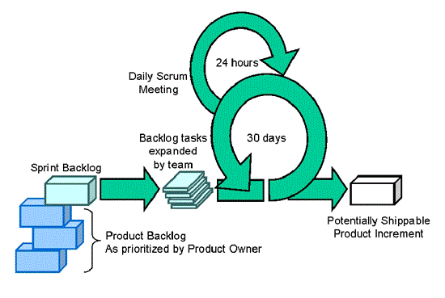

## Roles and Responsibilities

|  |  |  |  |
| --- | --- | --- | --- |
| STT | Full Name | Role in Group | Responsibilities |
| 1 | Lai Le Le Linh | Team Leader  Designer  Tester | - Create project plan, take meeting, check status, and monitor activities...of team members.  - Promote the project implementation and evaluate steps of project.  - Write meeting minutes  - GUI design  - Testing  - Create use-case diagram |
| 2 | Nguyen Duc Loc | Technical Leader  Developer | - Support other members about technical issues.  - Build framework and guide for developers.  - Coding  - Unit testing  - Create System Design |
| 3 | Nguyen Anh Tuan | Developer | - Create Database Design  - Coding  - Unit testing |
| 4 | Le Thi Minh Khanh | Tester  Designer | - Create test case  - Testing  - Design GUI  - Write meeting minutes |
| 5 | Nguyen Thi Gam | Tester | - Create SRS  - Testing  - Create documents, reports  - Write meeting minutes |

## Tools and Techniques

# Project Management Plan

## Task Sheet: Assignments and Timetable

## Risks Management

|  |  |  |  |  |
| --- | --- | --- | --- | --- |
| No | Risk Name | Level | Description | Solution |
| 1 |  |  |  |  |
| 2 |  |  |  |  |
| 3 |  |  |  |  |
| 4 |  |  |  |  |
| 5 |  |  |  |  |
| 6 |  |  |  |  |

## All Meeting Minutes

Here is a template for meeting minute within the project’s life cycle.

# Coding Convention